

**Palestine Technical University - Kadoorie**

**College of Engineering and Technology**

**Department of Computer Systems Engineering**

**Course name:**

**Software Engineering**

**Project title:**

**School Bus Tracking System**

**By :**

**Rawaa Abu Salah 202110394**

**Asma’a Dwaikat 202110467**

**Ruba Alahmad 202110638**

**Supervisor:**

**Dr.Osama Hamed**

**Spring semester 2023-2024**

**ABSTRACT**

the system is intended for parents and also the school administration, where a GPS device is placed on the school bus and the device is linked to a phone application, where the guardian registers in the application with the login information given by the administration and chooses the bus number, so that the bus location is then shown to prepare the children or to receive the children after the end of school and through This eliminates the problem of delay in waiting for the bus and also waiting for the bus before it arrives.

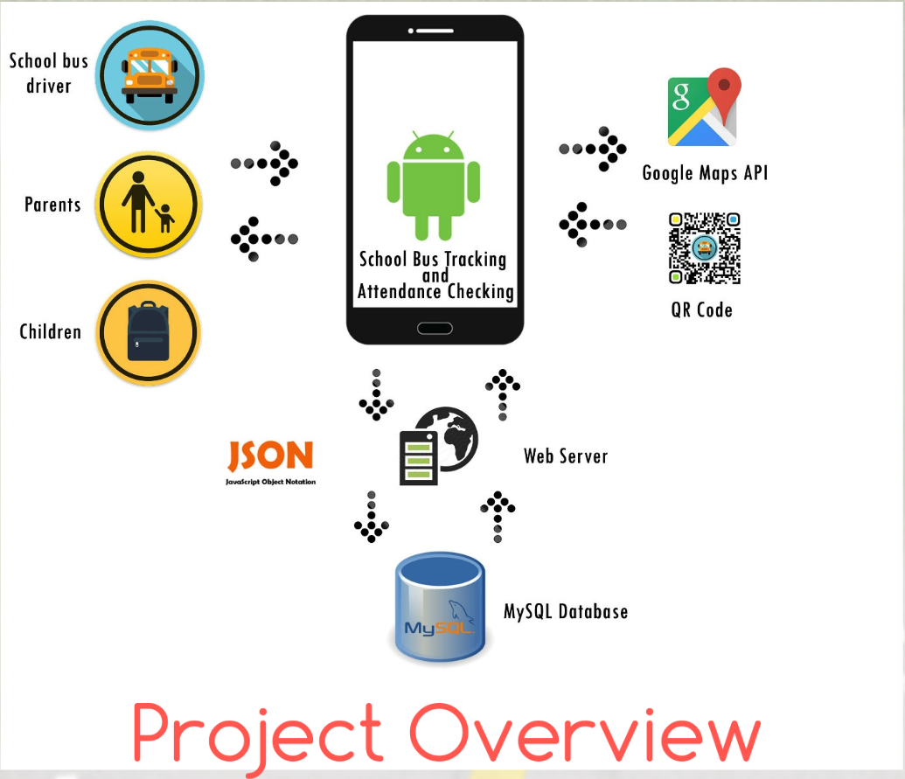

**CHAPTER 1: INTRODUCTION**

**1.1 Problem Statement:**

1- The bus is late for the specified time.

2-The anxiety and fear of parents for their children.

3- A technical problem or a specific failure on the bus.

4- Waiting for the bus for a long time or waiting for the bus before it arrives.

**1.2 Objectives:**

Our project aims to provide an integrated system to facilitate the transportation of students to and from school to achieve some goals:

1. To improve safety by monitoring driver behavior, tracking the bus route, and receiving emergency alerts.
2. To enhance communication by share trip information with parents, receive alerts when a student gets on or off, and send messages to parents.
3. To increase transportation efficiency by improving trip planning and reducing delays.

**1.3 System Features:**

1. GPS tracking devices are installed in every school bus to determine its location in real time.

2. The mobile application is available to parents and school administration, showing the bus location on a live map with additional information such as:

* Speed to monitor driver behavior and ensure safe driving.
* Expected time of arrival to facilitate planning for receiving students.
* Date of the trip to view the bus route date.
* Alerts:
* An alert when the bus approaches the student’s stop.
* An alert when the student gets on or off the bus.
* E-Alert in cases of unexpected delays or downtime.

3. Management platform is available for school management to monitor all school buses in real time, receive reports, and manage

Users.

**1.4 Project Target Groups:**

1-Parents.

2-Students.

3-School owners.

4-Bus drivers.

**ER Diagram**

